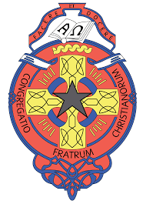

C.B.S. Charleville Secondary School
ANNUAL ADMISSION NOTICE
In respect of admission to the 2023 - 2024 school year

Admission Policy and Application Form
A copy of the school’s Admission Policy and the Application Form for Admission for the 2023 – 2024 school years is as follows:
To download at: www.cbscharleville.com
On request: By emailing reception@cbscharleville.com or writing to C.B.S. Charleville, Baker’s Road, Charleville, Co. Cork.

Part 1: Admissions to the 2023 – 2024 school year
Application and Decision Dates for admissions to 2023 – 2024
The school will commence accepting applications for admission on: | October 3rd 2022
The school shall cease accepting applications for admission on: | October 27th 2022
The date by which applicants will be notified of the decision on their application is: | November 11th 2022
The period within which applicants must confirm acceptance of an offer of admission is: | November 18th 2022
*Failure to accept an offer within the prescribed period above may result in the offer being withdrawn.
Note: The school will consider and issue decisions on late applications in accordance with the school’s admission policy.

Number of places being made available in 2023 – 2024
The number of places being made available in 1st Year is | 72
The number of places available in the Special Class all year-groups is | 3

