Finding VsWare ID
- Log into VsWare
- Click on your sons name on the dashboard –
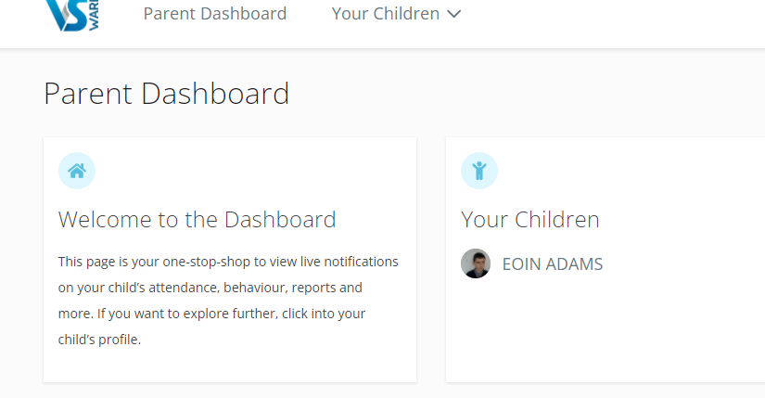
- Click learn more under personal information
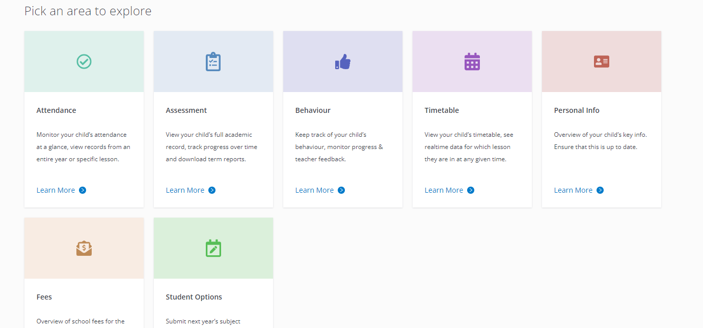
- Select the school tab on the top tool bar of the next page
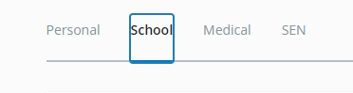
- Your VsWare ID should now be visible
